Case for Change
Workplace Health in the Creative Industries Consensus Statement
Draft launch material | August 2026

Why this matters
The relationship between employment and health is fundamental. Good work can provide fulfilment, purpose and social connection, while poor workplace environments can harm physical and mental health. The Creative Industries have distinctive ways of working that create both opportunities and particular workplace-health challenges.

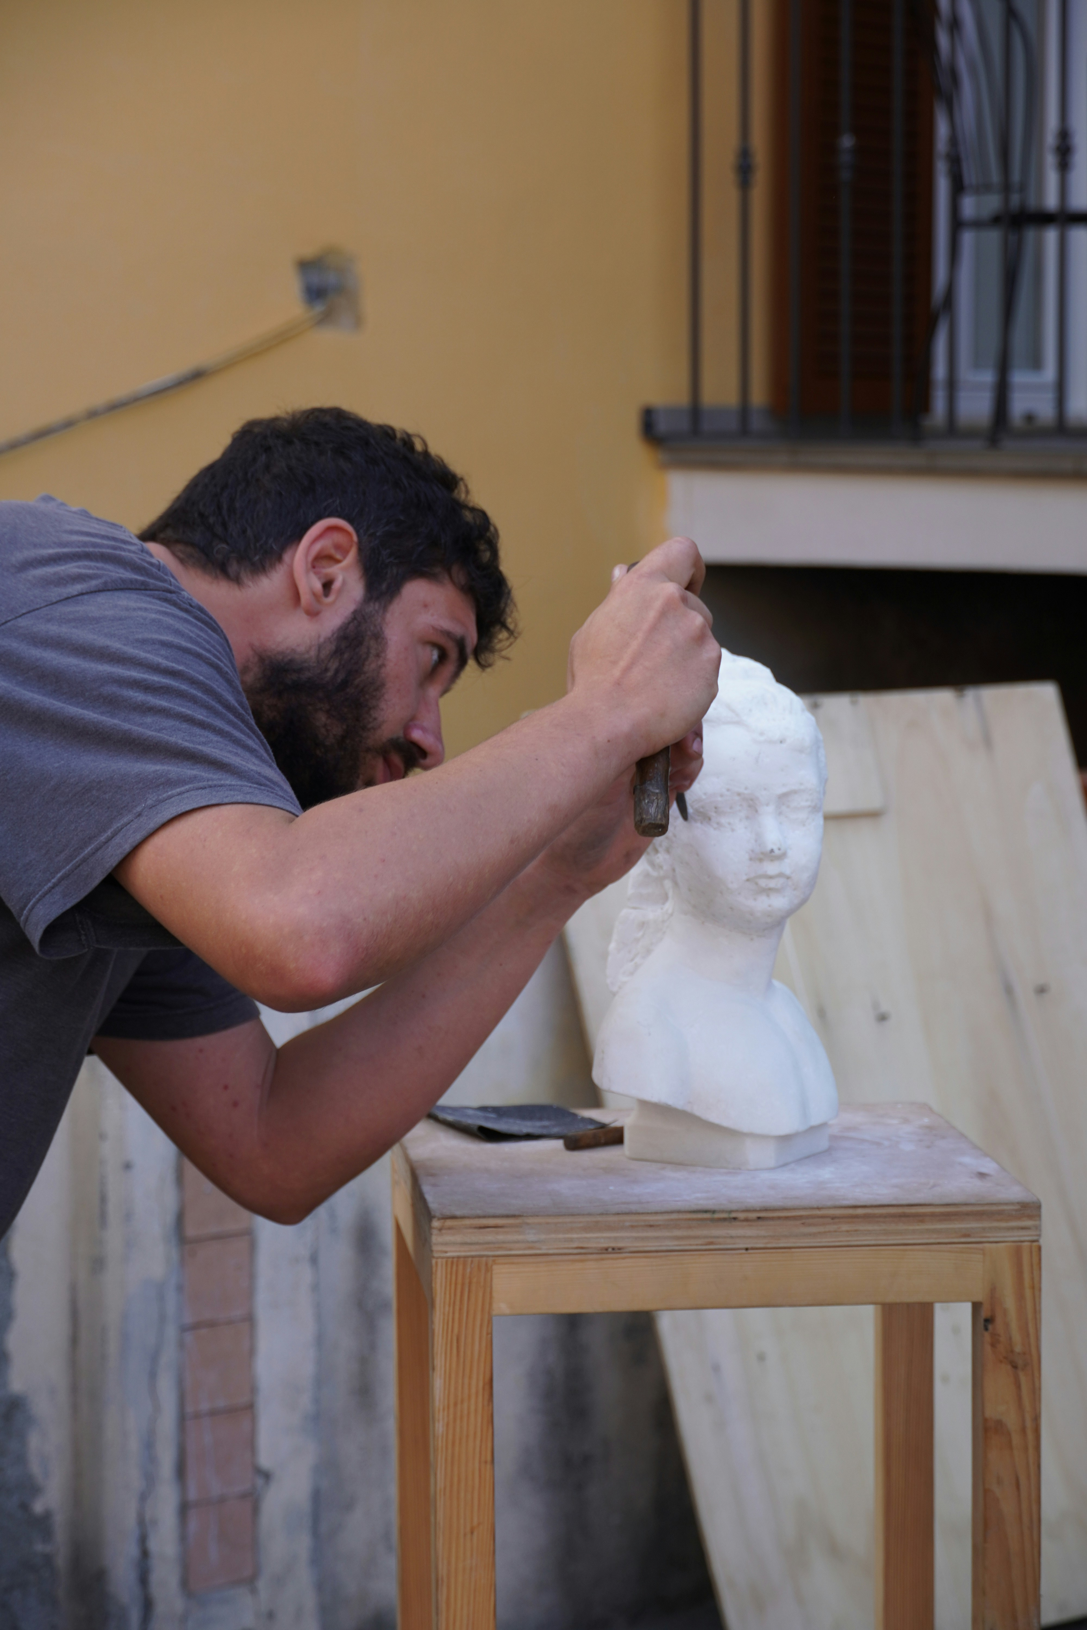
A major workforce and economic asset
The draft evidence identifies approximately 2.4 million jobs and £145.8 billion in economic output, around 7% of UK jobs. A healthy workforce is therefore important to economic sustainability as well as individual health.

Distinctive working arrangements

The workforce includes employees, freelancers, self-employed people, independent practitioners, fixed-term and project-based workers and volunteers. The draft identifies self-employment at 28%, compared with 14% nationally. These arrangements can make continuity of workplace-health support more difficult.

Health and financial pressures
The draft evidence highlights poor mental health, financial insecurity and occupational risks. In film and television, 35% of workers were reported to rate their mental health as poor or very poor. The evidence also identifies significant financial insecurity and limited access to employer-contributed pensions among self-employed musicians.


The opportunity
There is already substantial activity across Creative Industries, occupational health, education, professional bodies and Government. The opportunity is to connect this activity through shared ambition, common language and practical action rather than create competing infrastructure.



What the consensus asks
- Make public commitment as an organisation to improve health and wellbeing of staff, volunteers and contractors by signing the consensus.
- Embed workplace health in education, training and professional standards in the workplace.
- Increase understanding through evaluation, good practice and research.
- Strengthen recognition of workplace health as a core driver of a healthy, thriving Creative sector.
The launch is an invitation to move from shared recognition to practical action, proportionate to each organisation's role and resources.

