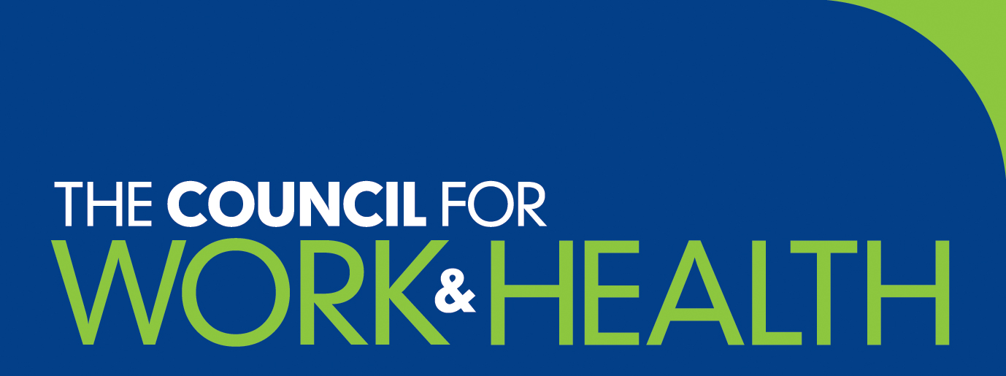

Briefing from Council meeting held on Tuesday 11 May 2021

National Work and Health Strategic Agenda

The representative from the Occupational Health Policy in the Work and Health Unit, Employers, Health and Inclusive Employment Directorate in the Department for Work and Pensions explained that they were still finalising timings on the release of formal response to white paper. She welcomed the opportunity to participate in the Council for Work and Health and offered to speak to a future meeting of Council once the next steps were public.

Steve Lee from the Health and Wellbeing team in the NHS People Directorate made a presentation on the NHS response and next steps to address Health and Wellbeing throughout the NHS. He shared an early draft of the Health and Wellbeing Dashboard showing six key indicators of staff wellbeing.

- Psychological safety climate - leading positive indicator
e.g., staff survey: ‘My immediate manager takes a positive interest in my health & wellbeing’
- Job Demands - leading negative indicator
e.g., vacancy rate, as a predictor of increased workload
- Job Resources - leading positive indicator
e.g., quarterly survey: ‘I am able to make improvements happen in my area of work’
- Healthy work environment - leading positive indicator
e.g., staff survey: ‘My immediate manager values my work’
- Stress / burnout symptoms - lagging negative indicator
e.g., sickness absence rate
- Positive health & wellbeing / engagement - leading positive indicator
e.g., Staff survey: ‘I look forward to going to work’

PHE update (National Institute for Health Protection in the Autumn)
The Chair reported on developments in this area and explained that nearly 10,000 staff now work within PHE control. Many will move forward in the new Health Protection agency. Some will join Department of Health (clinical policy specialists), some NHSEI (screening and immunisation leads), some NHS Digital (disease registration specialists) and a small number will pass to Care Quality Commission to support regulation work.

Marketing and Communications sub-group update (KB)
Thanks were extended to Karin Bishop for leading this group. Mandy Murphy, who had been re-elected to the Board, will now lead this group as Karin is no longer a Board member.

Governance sub-group update
It was reported that this sub-group will continue to review the terms of reference for Council and Board members.

Consultations
There were no specific current consultations to be considered but there is an NMC consultation underway on public and community health nursing registration until 2 August 2021.

Long-Covid
Ewan Macdonald had been invited to lead a short discussion on long covid which is emerging as a significant occupational health issue. He explained that long covid is really a new major multi-system disease which is not a good fit for current NHS pathways. The recently published SOM guidance argues that it needs good case management for rehabilitation which the NHS is not generally good at.

It was agreed that the Council should send a letter (or policy forming statement) to the four NHS Chief Medical officers in the UK on the importance of addressing long covid in a cross disciplinary way. Nick Pahl, SOM agreed to lead this work and several members volunteered to help.

Centre for Work and Health Research Centre
Ewan Macdonald gave a presentation on the need for a UK-wide centre for work and health research especially since were no longer part of the European Union. This would be cross disciplinary and engage with researchers in universities, health organisations and industry. It would not be in competition with the Council for Work and Health but would be complementary and provide evidence-based data to support work and health policy.

BACP proposal to support research on MHFA

The BACP project on mental health support is now progressing well with emphasis on improving the governance of mental health first aid and standards for providers. Kris would like to pass this guidance to CWH mental health sub-group for review/support to publish soon.

Website statistics
The latest website statistics were presented. It was noted that the numbers were up on last year.

Meetings attended by Board members on behalf of the Council

The Chair reported that he had been in regular contact with the WHU or Health and Inclusive Employment Unit as it is now called and NHSEI.

Discussions with Dr Will Ponsonby were on-going to ensure that Council and SOM continue to act in a ‘joined-up’ manner.

Members’ reports:
Members were asked for any written reports to be sent to the Deputy Chair for circulation with the minutes.

Any other business
It was noted that Robin Cordell was carrying out a review of SEQOHS (Safe Effective Quality Occupational Health Service) on behalf of FOM. Over the coming months he will consult widely among those who benefit from occupational health provision, currently and potentially in the future, those who are delivering occupational health services, and those commissioning services. Consultation will aim to encompass the range of people and organisations who have an interest in standards for promoting health, preventing ill health, and sustaining people with health conditions and disabilities in work. The review will consider not only how the SEQOHS process may continue to enhance safety, effectiveness and quality in the delivery of occupational health services, but also on how SEQOHS can bring further value to health and work through enhancing the outputs we produce, and the outcomes we create. He stressed that he would value comments and thoughts from Council. Please contact consultation@fom.ac.uk.

Close of meeting
The Chair thanked everyone for their time and input, both to the meeting and to the ongoing health and work agenda.

The next meeting of the Council is scheduled to take place on Monday 13 September 2021

